**Integration of point of care testing in primary health care facilities for early comprehensive management of sickle cell disease in the Kassena Nankana Districts of Ghana.**

**Summary**

**Background:** Sickle cell disease is highly prevalent in sub-Saharan Africa which accounts for 50-90% mortality rates. Newborn screening for early diagnosis and enrollment of affected children is crucial. In sub-Saharan Africa, limited access to specialized care facilities and the high cost of laboratory-based diagnostic tests have hindered early diagnosis and timely interventions for children with SCD. Our study evaluated the feasibility and acceptability of integrating point-of-care testing for SCD at primary healthcare facilities for linkage to early comprehensive SCD care.

**Methods:** Building on the existing routine immunization programme we did a prospective study at 10 primary healthcare centres in Kassena-Nankana Districts. We systematically screened sickle cell disease among consecutive newborns and infants under 5 years who presented the immunization clinics at these 10 facilities using the Gazelle point of care testing device.

**Results:** Between August 2022 and September 2023, 6024 newborn babies and infants who presented for immunization were screened for sickle cell at 9 primary health care facilities and 1 hospital using the Gazelle point of care test. Our findings indicated 3971(66%) children had normal hemoglobin (HbAA), 1149 (19%) HbAC, 720 (11.9%) HbAS, 106 (1.8%) HbCC, 58 (1.0%) HbSC, and 23 (0.3%) HbSS. We identified 81 children with sickle cell disease. 79 of them have been retained in care with 2 lost to follow up.

**Conclusion:** Our findings demonstrated that the integration of POCT screening into existing primary healthcare programs, leveraging the high level of immunization coverage, is feasible and can be rapidly implemented in remote areas with limited resources. The prevalence rate from this study is comparable to previous screening efforts with laboratory-based techniques in other parts of the country. All screen-positive patients, except for two who relocated to another region, were referred for SCD management and first clinic visit adherence was 100%. We continue to provide follow-up care to the patients and monitor long-term clinical outcomes. The experience from this study will be used to scale up to other parts of the district and the Upper East Region of Ghana as a whole.

INTRODUCTION

Sickle cell disease (SCD) remains a significant public health challenge, particularly in sub-Saharan Africa, including Ghana. More than 75% of the global burden of sickle cell anemia(SCA) occurs in sub-Saharan Africa, where limited health resources and insufficient awareness among healthcare providers and the general public contribute to alarmingly high rates of early mortality. The global all-age mortality rate of individuals with (SCD) is nearly 11 times higher than the cause-specific mortality rate of individuals with SCD. Further, the highest burden of mortality from SCD is concentrated in Sub-Saharan Africa, where the total number of deaths of individuals with sickle cell disease is nearly 9 times higher than the cause-specific deaths of individuals with SCD. Sickle cell disease affects about 300,000 infants annually. In 2021, Ghana was recorded as one of the countries with SCD incidence at birth between 1000 to 2000 per 100000 live births. Mortality rates are highest in children under-5 and the WHO estimates that SCD contributes to 9-16% of under-5 mortality in certain regions of West Africa, imposing physiological, mental, and financial burdens on affected individuals and families. Without widely available newborn screening(NBS) or early access to comprehensive care, the mortality rate is usually high and without any proper intervention the mortality rate is going to increase.

Despite its high prevalence, early diagnosis and comprehensive management of SCD in resource-limited settings are often hindered by the high cost of laboratory-based diagnostic tests and limited access to diagnostic facilities and specialized care. NBS is critical in bringing the diagnosis to the attention of both parents and health workers, however it is worth noting that screening without linking to care is not complete. without access to education about disease condition during the screening linkage to care may not be achieved. The inadequate infrastructure in most health facilities presents a significant impediment to the implementation of universal newborn screening in sub-Saharan Africa. Introducing Point-of-care testing (POCT) may address these challenges by enabling rapid diagnostic testing at the site of care, providing immediate results to families and health workers and immediate linkage to comprehensive care. Over the past 25 years, pilot programs have included less than 5% of newborns in Ghana in these screening programmes. Several interventions such as vaccinations, hygiene and sanitation coupled with early diagnosis could contribute to the reduction in mortality of SCA patients. S 4caling up or establishing universal newborn screening has proven to be challenging over the decades. Leveraging existing primary health care services which already have extensive coverage, including immunization programs, without needing to create new infrastructure, offers great potential for seamlessly integrating newborn screening.The integration into primary health care facilities represents a transformative approach to managing (SCD), particularly in rural regions like the Kassena Nankana Districts of Ghana. This is crucial for SCD, where early intervention can significantly alter the disease trajectory and enhance the quality of life for affected individuals. By utilising advances in mobile health technologies and portable diagnostic devices, primary healthcare facilities can provide comprehensive management strategies that are both efficient and accessible.

Early identification of affected individuals allows for timely interventions, such as prophylactic treatment, genetic counselling, and immunization, thereby reducing morbidity and mortality associated with the disease. Our study, therefore, evaluated the feasibility and acceptability of integrating point-of-care testing for SCD at primary healthcare facilities in the Kassena-Nankana Districts in the Upper East Region of Northern Ghana for linkage to early comprehensive SCD care. We have previously reported and demonstrated in the feasibility part of the study, facilitators and barriers for integration with strong evidence of community acceptability and feasibility.

METHODS/ MATERIALS

**Study design**

This was a prospective observational study design leveraging implementation science-based methods to facilitate successful integration of POCT device (Gazelle) as a screening tool for SCD in community health compounds and immunization clinics, and initiate care and referral pathways for early and comprehensive disease management.

**Study site**

The study took place in 10 health facilities located in 2 districts in the Upper East Region which are the Kassena Nankana Municipal and Kassena Nankana West District. The study was implemented in four CHPS compounds, five health centers, and one hospital. The CHPS and health centers serve as primary healthcare facilities and the first point of call for these participants, and the hospital is a secondary facility as well as a referral facility for these primary facilities. We selected the hospital because of the sickle cell clinic which was set up at the hospital. The choice of the two districts was based on the coverage of the Navrongo Demographic and Health Surveillance Systems which covers the two sites and will facilitate tracking of cases in the community.

The Kassena-Nankana Municipal was previously known as the Kassena-Nankana East District after it was carved out of the Kassena-Nankana District. According to the Population and Housing Census, the population of Kassena Nankana Municipality is 109,944. Males constituted 48.8 percent of the population. Approximately 72.7 percent of the population lives in rural areas. The Municipality had a sex ratio of 95.4. The municipality lies between latitudes 11°10' and 10°3' North and longitudes 10°1' West. It is bounded by seven districts: on the North by the Kassena Nankana West District and Burkina Faso, on the East by the Bolgatanga Municipality, Talensi District and Bongo District, on the West by the Builsa South and Builsa North Districts and on the South by Navrongo Health and Demographic Surveillance System

The Navrongo Health and Demographic Surveillance System (NHDSS) covers the two Kassena-Nankana areas – the Kassena-Nankana West District and the Kassena-Nankana Municipal. Operationally, the surveillance area has been divided into five zones (North, South, East, West and Central), and these have been further divided into 247 clusters.

The NHDSS monitors health and demographics of the two Kassena-Nankana districts (Kassena -Nankana East and West) including morbidity and mortality assessments. The total population under surveillance as of June 2018 was 167,000 residing in 42000 households (NHDSS Annual report 2018). The NHDSS provides a platform for the conduct of longitudinal studies for evaluation of health and social interventions. Trained fieldworkers visit each compound every six months to interview heads of households. Data that are collected routinely includes marriages, pregnancies, births, deaths, migrations, vaccinations and verbal autopsies (VAs). Information on household socio-economic characteristics is updated every other year. The platform serves as a control system for other health indicators in Ghana and supports assessments of public health interventions (NHDSS Annual report 2018).

**War Memorial Hospital**

The War Memorial Hospital served as our referral facility, located in the Kassena-Nankana East Municipality. The War Memorial Hospital (WMH) is the only referral facility for the two Kassena-Nankana districts and adjoining districts including Builsa and Sissala West.

The War Memorial Hospital has a total bed capacity of 169 comprising a Neonatal Intensive care unit 11, Pediatrics ward 43, Male surgical 16, female medical 22, Male Medical 16, Female surgical 21, Emergency ward 11, Labour ward 5 and maternity ward 24. The WMH has staff strength of 324 comprising, 6 medical officers, 3 Physician Assistant, 43 midwives, 101 general nurses and 82 enrolled nurses.

**Study facility Selection**

The total number of CHPS compounds and Health centres were collected from the District Health Directorate in the 2 districts. The Health Information officer assisted with selecting the CHPS compounds and health centres, this selection was made based on the number of deliveries that were conducted over the previous year 2021. Facilities with higher births rates were purposively selected as a study site.

**Study Participants**

Children aged 5 years and below who are presented at Immunization clinics and delivery centers in the selected health facilities and provided consent were included in the study.

**Data Collection**

Data was collected between August 2022 to September 2023. Trained health workers(Community health workers or midwives) at the various facilities were used for the data collection process. Children who were presented at immunization clinics and after delivery were included in the study. Mothers/caregivers were approached for consent, the consenting process explains to the mothers/caregiver what the study is, and the procedures to be involved. Once the mother agreed to participate in the study, a consent form was signed, and the child was enrolled.

**Data Sources**

Using a standardized questionnaire, we collected information related to the sociodemographic parameters of the mother which included Mothers name, house number, profession, residence, phone number and ethnicity. In addition, information on newborns or toddlers was collected i.e age, sex, date of birth, weight, birthplace, transfusion history and whether child was born a twin.

Information on screening results, site of testing, follow-up results and confirmation into the clinic was also collected.

**Sample procedure**

From each participant 20ul of blood was collected from the heel or thumb using the BD Microtainer Contact-Activated Lancet (Becton, Dickinson and Company, New Jersey, USA) performed by trained midwife or laboratory personnel; the first one was wiped with cotton wool, and the second was then drawn into an Eppendorf tube and mixed with 40ul of the marker fluid, vortexed for 20s to lyse the blood. 50ul of the Gazelle buffer was pipetted and placed into the cartridge and inverted for 1 min. 20ul of the mixed sample was pipetted onto a glass slide, and a stamper was used to collect the sample from the slide, placed unto the stamper stand, and held for 5s. The cartridge is flipped over and 200 buffer is pipetted into two wells on the cartridge. The cartridge was inserted into the test strip machine and the gazelle POCT device.

**Data Analysis**

Data was entered into the Newborn screening App, dataset was then exported into excel and cleaned for missing values, anomalies, and consistency of responses. Data analysis was done using STATA 15.0. We calculated the proportion of newborn babies and infants with sickle cell anaemia (HbSS), heterozygous for HbS and HbC (HbSC), with sickle cell trait (HbAS), heterozygous for HbA and HbC (HbAC), and with normal haemoglobin (HbAA). We used 95% CIs based on Fisher’s exact test to reflect uncertainty related to the sample size, rather than the accuracy of the point-of-care screening test.

Sickle SCAN

Sickle SCAN is a multiplexed, qualitative, point-of-care immunoassay capable of identifying the presence of haemoglobin A, S and C. It is a rapid lateral flow immunoassay kit, which can accurately diagnose the most common forms of SCD (HbSS and HbSC) while clearly distinguishing between normal, Sickle cell disease and Sickle cell trait. Sickle SCAN has both a combined sensitivity and specificity of >99% and provides results in 5 minutes. The test is conducted by simply mixing a drop of blood with the buffer provided in the Pretreatment module to release haemoglobin by lysing erythrocytes. Five drops of the treated sample are dispensed from the Pretreatment Module and introduced into the Sickle SCAN cartridge sample inlet. The sample undergoes a 5-minute flow through the test cartridge before the result is read. A total of four detection lines are possible, with the control (Ctrl) line appearing when the sample has been flowed through the cartridge. The presence of hemoglobin variants A, S, and C will be indicated by blue lines in their respective regions. (For example, if a line appears at both HbS and HbC, this suggests a diagnosis of HbSC disease). (3,

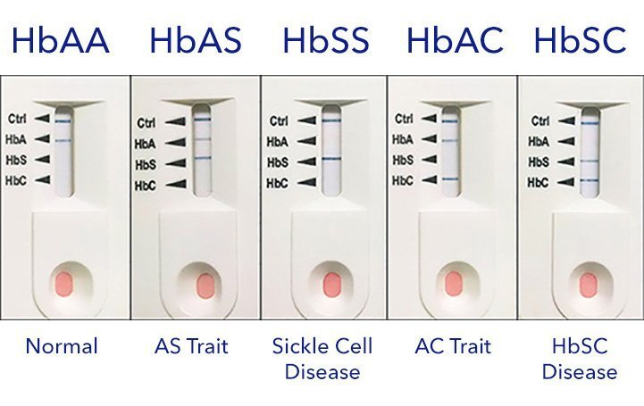

Gazelle Hb Variant

Gazelle Hb Variant is a miniaturized version of the gold standard test known as cellulose acetate electrophoresis. It utilises a miniaturised, microchip-based cellulose acetate electrophoresis contained within a portable, battery-operated device.   A blood sample is collected from the patient using a finger prick or venipuncture, and the collected blood sample is prepared, which involves pipetting the sample into a specific cartridge designed for the Gazelle. The prepared cartridge containing the blood sample is inserted into the Gazelle device. Results are displayed in 8 minutes, including hemoglobin percentages by type, and can be stored locally or transmitted to the Cloud for patient and disease tracking. The device is designed to minimize user error, featuring step-by-step instructions on the screen. It has built-in quality control features that detect errors during the testing process. If an error occurs, the device prompts for a retest, ensuring accurate results.

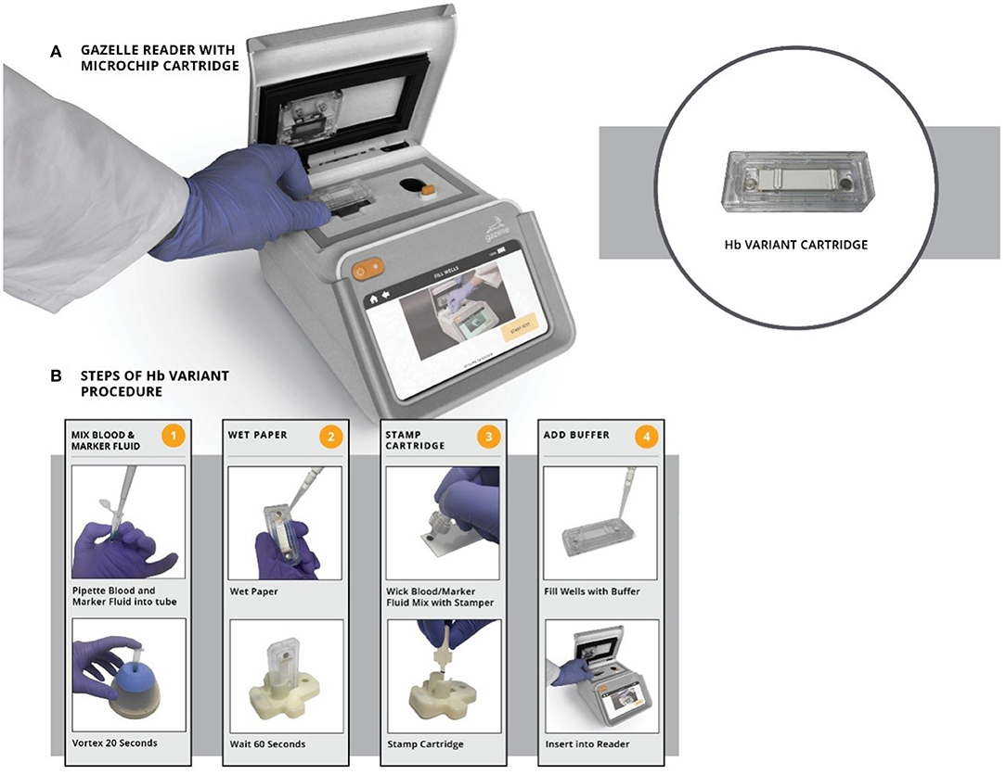

**THE SICKLE CELL CLINIC**

Prior to the initiation of the study, a sickle cell clinic was established at the War Memorial Hospital, Navrongo, to specially cater for the needs of SCD patients. The treatment team was composed of a visiting pediatric hematologist, 3 medical officers, 4 nurses and a clinic coordinator. Periodic training was provided for the medical officers and nurses to equip them with the knowledge and skills necessary for managing sickle cell disease. Regular phone consultations with the pediatric hematologist were also conducted.

**The Referral Pathway**

Prior to entry into the study, SCD screening was done at the various peripheral facilities for children under-5 using a POCT device. Children who had normal results were counselled and results given to them while children who were identified as possible sickle cell patients were referred to the clinic for confirmation with the sickle scan, once confirmed they were enrolled into the study. Those whose results did not conform with the sickle scan were asked to repeat the test in 3 months, once their results were confirmed they were counselled and discharged as Normal.

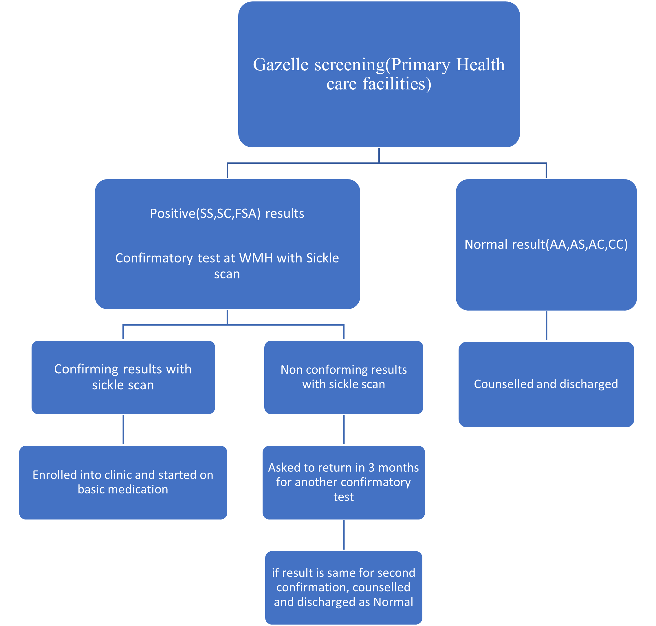

**First Clinic Visit**

A confirmatory test was performed using a sickle scan device at the first clinic visit for patients who had tested positive during the screening and had been referred. Patients with SC or SS genotype were then enrolled in the study. Upon entering the study, we took a comprehensive history from each patient and conducted a thorough physical examination for each one. We collected the patient's medical history, such as the frequency of acute events prior to the visit, hospital admissions, blood transfusions, and medications. We also gathered family history, including the number of siblings and whether their genotypes were known.

Additionally, the parents of these children received counselling and comprehensive information about sickle cell disease in languages that were easily understandable, including English and local languages such as Kassem, Nankam, or Twi. This information was provided on an individual basis. Emphasis was placed on identifying SCD acute events, their triggers, and implementing preventive measures. Education was conducted in a hospitable and comfortable setting, enabling parents to exchange their knowledge, perspectives, concerns, and experiences regarding the ailment. Furthermore, inquiries, misconceptions, and truths regarding the condition were thoroughly discussed. Parents were also advised to ensure their children adhere to prescribed medications and attend scheduled clinic appointments. Parents were provided with training on spleen palpation and were requested to perform the technique during subsequent visits.

PATIENT CARE AND FOLLOW-UP VISITS

The patients were scheduled for follow-up visits based on their condition upon entry into the study, their genotype, and whether they were receiving HU therapy. Children who had already started experiencing complications or acute events before enrollment into the clinic were seen more frequently (at least once or twice a month) until they were more stable. Patients on HU therapy were scheduled for visits on week 2, week 4, day 90 and 3 months from the start of HU to monitor for possible toxicity and to ensure compliance with the treatment.

When a patient required hospitalization during the study, they were admitted to their various peripheral facilities for management. Their treatment plan occasionally involved consultation with the study treatment team, or a referral was initiated to the War Memorial Hospital when necessary. Patients who presented to the sickle cell clinic with an acute event that required hospitalization were admitted to the pediatric unit at the hospital, and the study treatment team was responsible for the in-patient management.

**BASIC TREATMENT**

All patients were started on folic acid (1mg/d for children< 1yr, 5mg/d for children> 1yr), vitamin C and Zinc-containing multivitamin. Oral penicillin was started at 2 months old (125mg bd for children 2months-3yrs and 250mg bd for children 3-5yrs). Regular use of an insecticide-impregnated bed-net was advised to reduce the risk of mosquito bites.

**HYDROXYUREA(HU) THERAPY**

The use of hydroxyurea was dependent on the age and genotype of the patients. Patients with SS genotype and at least 9 months of age were eligible for hydroxyurea therapy. Prior to commencing HU, adequate counselling sessions were ensured and parents were given the opportunity to accept or decline the initiation of HU therapy. Baseline laboratory testing was done, and patients were started on dispersible hydroxyurea tablets(18-20mg/kg/day) if the criteria were met. Hydroxyurea was given to patients at no cost to them.

**Ethical approval**

The study was reviewed and approved by the Navrongo Health Research Centre IRB (**Approval ID: NHRCIRB451**) and Ghana Health Service Ethics Review Committee (**Approval ID:GHS-ERC 015/03/22**) before the commencement of the study. Written consent was obtained from all participants. To ensure confidentiality of participants information, participant IDs were assigned to participants.

**Results**

**Study Population**

Between August 2022-September 2023, 6024 consecutive newborns and infants under 5 years of age were screened with 81 screen-positive children who completed confirmatory diagnosis at first SCD clinic visit. Slightly more of the children screened were males (50.3%) , Table 1. Our findings indicated 3971(66%) children had normal hemoglobin (HbAA), 1149 (19%) HbAC, 720 (11.9%) HbAS, 106 (1.8%) HbCC, 58 (1.0%) HbSC, and 23 (0.3%) HbSS. Thus, 81(1.3%) children had SCD, 79 of whom were enrolled in care for penicillin V prophylaxis and folic acid. Except for two children who relocated to another region, all 79 participants were maintained in care with no loss to follow-up, facilitated by periodic home visits by community health nurses at the various testing sites. 23 HbSS patients with mean age of 23.4 ± 17.1 months were initiated on hydroxyurea therapy. All patients continue with follow-up care facilitated by community health workers and tele-health referral platform for long-term clinical outcomes.

|  |  |  |
| --- | --- | --- |
| **Characteristic** | **Frequency (N=6024)** | **Percent (%)** |
| **Age (Median [IQR])** | 15 (27) | |
| **Age category (Months)** |  |  |
| 0 – 11 | 2483 | 41.2 |
| 12 – 23 | 1377 | 22.9 |
| 22 – 35 | 885 | 14.7 |
| 36 – 47 | 734 | 12.2 |
| 48 – 59 | 545 | 1.0 |
|  |  |  |
| **Gender** |  |  |
| Female | 2992 | 49.7 |
| Male | 3032 | 50.3 |
|  |  |  |
| **Haemoglobin types** |  |  |
| HbAA | 3971 | 66.0 |
| HbAC | 1146 | 19.0 |
| HbAS | 720 | 11.9 |
| HbCC | 106 | 1.8 |
| HbSC | 58 | 1.0 |
| HbSS | 23 | 0.3 |
|  |  |  |
|  |  |  |
| **Age category of SCD positives (Months)** |  |  |
| 0-11 | 28 | 34.6 |
| 12-23 | 18 | 22.2 |
| 24-35 | 11 | 13.6 |
| 36-47 | 14 | 17.3 |
| 48-59 | 10 | 12.3 |
|  |  |  |

*Table 1:characteristics and screening results for study participants*

**Clinic Follow up**

Families of infants with FS or FSC screening results were scheduled from the testing sites to come for confirmation at the War Memorial Sickle cell clinic. A total of 273 participants had a presumptive SCD and were confirmed out of that number 84 were confirmed as true positives with 81 participants having either 23 FS or 58 FSC and 3 SFA. To date 79 out of the 84 have been eligible for clinic and also these patients have been successfully contacted and enrolled into the clinic for follow up care.2 participants had travelled out of the region. All participants were started on Folic acid supplements, Penicillin V and Vitamin C and Zinc Supplements.

Figure 3: Frequency distribution sickle cell disease by age category in months

**Clinic Visits**

Over the one-year period, 40 clinic visits were made by the FS and FSC patients. Approximately 95% made 5-10 clinic visit,75% made 11-20 clinic visits and 90% made >20 clinic visits.

**Hydroxyurea Treatment**

The use of hydroxyurea was dependent on the age and genotype of the patients. Patients with SS genotype and at least 9 months of age were eligible for hydroxyurea therapy. Prior to commencing HU, adequate counselling sessions were ensured, and parents were given the opportunity to accept or decline the initiation of HU therapy. Baseline laboratory testing was done, and patients were started on dispersible hydroxyurea tablets(18-20mg/kg/day) if the criteria were met. Hydroxyurea was given to patients at no cost to them. 23 HbSS patients were started on the hydroxyurea drug at 9 months of age. Before the medication starts they do chemistry tests such as RFT AND LFT as well as full blood count. They come for periodic reviews.

**Education**

A total of 40 health workers trained on the basics of SCD, the screening process, the usage of the Gazelle device as well as disclosing of results and counselling of screened positive participant. The heath workers included Community health Nurses, enrolled nurses, midwives, and lab technicians. The health workers were also trained in the use of the NBS App to capture the background characteristics of the participants.

**Discussion**

The findings from our study demonstrates that newborn screening for sickle cell disease using point of care testing is feasible and can be scaled up in local primary health care centres by building on existing immunization programmes with limited human and financial resources for detection and follow up in low resource settings.

Newborn screening leads to reduction in mortality and morbidity through early identification and commencement of early care including initiation of penicillin prophylaxis, pneumococcal vaccination, counselling of parent and providing other routine medications. In Ghana newborn screening was introduced in 2010 with the aim to identify and follow up children who test positive for sickle cell enrolling them for comprehensive care.

Through screening of 6024 children, we identified 81 sickle cell disease case of whom 79 will be followed up for the next 5 years. These patients have been enrolled in comprehensive care. The noted prevalence of 1.3% found from our studies has been consistent with other studies. A similar study in Abuja, Nigeria reported a prevalence of 1.4%. Our study recorded more patients with SC (1.0%) as compared to SS(0.3%). This finding is quite the opposite of what was seen in a study conducted in Kumasi with the study having more S(1.04%) than SC(0.83%). This could be because the northern part of the country has more C hemoglobin. One uniqueness about our study is that testing was done with the Gazelle device and later confirmed with the sickle Scan. This gives instant results encouraging for early referral and intervention. The gazelle gives the quantitative component of the results indicating the percentages of the haemoglobin types.

All the infants diagnosed with SCD were immediately enrolled into comprehensive care and were followed up. First Clinic visit 100%, however, some doubted their results and didn’t believe their children could have the condition as they didn’t even know their status, this encourages universal infant screening for early diagnosis and initiation of care before the onset of symptoms. 23 SS patients were placed on hydroxycarbamide to improve the outlook of their condition.

Screening programmes, however, have not gone beyond small scale projects due to practical and financial constraints to set up and access interventions for early diagnosis and management of sickle cell disease. An estimated 242,000 infants are born with SCD in sub-Saharan annually and the majority of those do not have access to newborn screening, many labs do not have the infrastructure to run these tests.

Our pilot study enabled us to reach most babies born during the study period and demonstrated that using point of care was easy to perform and interpret facilitating prompt delivery of results. Education and counselling of a positive screen led to a high rate of attendance at follow-up clinic.

The integration of point-of-care testing in primary health care facilities for early comprehensive management of sickle cell disease is a crucial step towards improving patient outcomes and reducing healthcare disparities. This approach involves implementing rapid, on-site diagnostic tools that can quickly identify sickle cell disease (SCD) and its complications, allowing for immediate intervention and treatment. By bringing these testing capabilities directly to primary care settings, healthcare providers can offer more timely and targeted care to patients with SCD, particularly in underserved or remote areas where access to specialized hematology centers may be limited.

Additionally, this approach can enhance patient education and engagement, as healthcare providers can use immediate test results to discuss treatment plans and lifestyle modifications with patients in real-time. This immediate feedback loop can significantly improve patient understanding of their condition and increase adherence to treatment regimens. Furthermore, the availability of point-of-care testing in primary care settings can reduce the need for frequent visits to specialized centers, thereby decreasing the burden on patients and their families in terms of time, travel, and associated costs.

From our previous study on barriers and facilitators of sickle cell screening, some barriers identified were understanding of the disease, traditional beliefs surrounding the disease and confidentiality in disclosing results. Both community members and health professionals suggested various strategies such as intensive health education, short duration of screening processes and screening health workers not being biased could promote community acceptability of SCD screening in the area. In the previous study, most participants believed that effective and continuous community education and sensitization could promote community acceptability and uptake of the SCD screening exercise. More importantly, providing evidence-based education on similar exercises carried out by the Navrongo Health Research Centre in the past to improve health outcomes in the area and announcements on community media stations have been highly recommended to create awareness and understanding about the benefits and need for parents to accept the SCD screening exercise.

The challenges stated by the participants from the previous study were mitigated by the high sensitivity and rapid results of the POCT, adequate counselling and confidentiality of result was ensured.

**Conclusion**

The main lesson is that a newborn screening program is needed and is practical in Ghana. In the 13 months of piloting NBS at selected facilities, there was success in counseling women at delivery, collection of blood samples from newborns, identifying newborns with SCD and introducing them to comprehensive care. The feasibility of the program has been mainly due to the approach of selecting primary health care facilities, integrating screening services into existing immunization services. Our pilot study confirms that Ghana has a high burden of sickle cell cases. The integration of newborn screening into existing primary health-care immunization programmes is feasible and can rapidly be implemented with limited resources. Point-of-care tests are reliable and accurate in newborn screening for sickle cell disease and prompt referral for management to reduce the burden of sickle cell in Ghana. This feasibility study bodes well for the care of patients with sickle cell disease in resource-poor countries. The experience from this study will be used to scale -up to other parts of the districts and the Upper East Region as a whole.

**Acknowledgement**

The authors would like to express their profound gratitude to all the study participants for sharing their willingness to participate in the study. We thank the Regional Health and district directorate for their immense support before the data collection process started.

**Competing Interest**

None declared

**Funding**

This study was funded by Novartis

References

1. [Patrick T. McGann](javascript:;), [Arielle G. Hernandez](javascript:;), [Russell E. Ware](javascript:;) (2017) Sickle cell anemia in sub-Saharan Africa: advancing the clinical paradigm through partnerships and research. ASH Publications, [https://doi.org/10.1182/blood-2016-09-702324](https://doi.org/10.1182/blood-2016-09-702324" \t "_blank)
2. Nkya S, Mtei L, Soka D, Mdai V, Mwakale PB, Mrosso P et al. (2019) Newborn screening for sickle cell disease: an innovative pilot program to improve child survival in Dar es Salaam, Tanzania. *International Health*, 11(6): 589–595. pmid:31145786
3. [Daniel Dexter](https://onlinelibrary.wiley.com/authored-by/Dexter/Daniel), [Patrick T. McGann](https://onlinelibrary.wiley.com/authored-by/McGann/Patrick+T.) (2021) Saving lives through early diagnosis: the promise and role of point of care testing for sickle cell disease. British Journal of haematology, <https://doi.org/10.1111/bjh.17678>